

 Eureka! Project -White paper-

Your Smart Social knowledge base.

**Introduction …**

We are now in the information age, where a single piece of data can make a huge financial difference, where the most powerful players are not those with the most muscle or money, but those with the most knowledge at their fingertips.

This goes some way to explain the incredible competition for data among the big tech companies and is of particular relevance for social media businesses since their data can be a key differentiator in how the next generation products and services are designed and delivered.

From another perspective, speed is also critical nowadays, even the most pertinent information can be useless if it arrives too late. Another important factor is whether or not the source of information can be trusted. No one will be interested in fake or misleading information.

Considering the various ways to obtain knowledge and domain-specific information in general, it is clear that the internet is the biggest & fastest currently available resource, on a range of different topics and bodies of knowledge. That said, it is also clear that the internet suffers from some significant issues and is far from the ultimate source of expert knowledge.

In spite of the huge leap that the internet can offer in terms of the scope of knowledge sharing and information availability, there are still many gaps in that same knowledge and expertise, especially when we consider that the deep Web is approximately 400 to 550 times larger than the information that can be accessed directly through Web pages.

This is exactly what we aim to solve with our Eureka! Project. We want to provide a way to ensure that any kind of information, even those not well represented on a website, online video or a blog, can be retrieved immediately from a trusted source! We have considered this problem at length, and when we discovered the solution, we said Eureka!

" Eureka!" as a name comes from the [Ancient Greek](https://en.wikipedia.org/wiki/Ancient_Greek) word [εὕρηκα](https://en.wiktionary.org/wiki/%CE%B5%E1%BD%95%CF%81%CE%B7%CE%BA%CE%B1) heúrēka, meaning "I have found (it)", and for our project it’s the solution that will help users everywhere to search for any piece of knowledge and find the answer online immediately from the right person; the person with a complete knowledge about your question, who also stands to make money. In addition to this, by keeping track of all data in the system, we can leverage the strengths of big data analytics to create valuable resources like trends, facts, insights, reports …etc.

From a business perspective:

you will create new business and partnerships with your users and clients, enabling your users to make money through partnership programs and to earn a profit from clients’ ads.

In the next few pages, we will go more deeply into the details about the idea of the project and how it works, with more focus on the analytics part, and the business perspective.

So, let’s go …

Eureka! , **What is that?**

What is that?

Eureka! Simply put, we propose an online solution that enables the user to easily ask any question for free in any field of knowledge whatever the level of simplicity or sophistication.

We have also taken into account ethical standards and suitable privacy levels, using the concept of a social search engine to generate results for matching user profiles and available experts, in order to get an immediate response from a trusted person who also answers the question as promptly and accurately as possible, due to a suitable financial incentive.

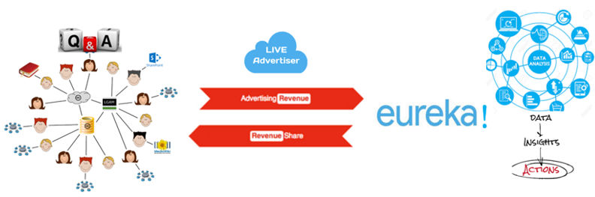In addition, a big hub for all previously asked questions that both persons (the one who asked and the responder ) have agreed to be published on this public hub, that any user can browse at any time for their reference.

but in fact, the project has **two** sides …

The users /clients side: that we have just explained which is the users facing side that it’s all about interactive & smart social knowledge base that user can ask and /or answer questions

They can ask for free and also can answer question with a portion of money for each single question through the partnership programme that we have with our sponsors and advertisers

The Business & Analytics side: which is the back end of our solution and the critical side as we will ingest the data that we gather from

* users (profile basic information, related social network accounts data, interests, hobbies, experiences,)
* questions that frequently asked and it’s related answers

**to create**: Ready surveys, insights, Trends, facts, reports, consumer & market behaviour & decisions for different associations that could be interested in these critical data

the importance of big data analytics and being able to apply the cognitive Algorithms to make the most use of data is the most critical part of our project and the smartest as well.

Eureka!, **How it works?**

* In a simple way the new user for Eureka! should sign up in the first time as normal to create his profile and answer some basic obligatory questions that could include his personal information, his interests, hobbies , times that he normally would be online ,PayPal or bank account to recive money and areas of knowledge that he could accept to receive questions about for free



* The user will be optionally asked to provide his social media accounts like facebook, linked in & google plus for account verification and to let Eureka! gather more information about your interests, career and experience

*The more optional information that user would provide the more profile score he can get,

**User profile score affect his rank and his priority in search results for asking users

* The user account will be also verified through SMS & mail verification, and once the user complete his registration and accept the [Terms of Service](https://www.facebook.com/terms) he will be able to ask any questions and answer questions assigned to his profile according to his area of interests he mentioned also he will be able to surf the public hub for all answered questions in different categories

Also, an **invitation** will be sent to all his friends in other social media websites he attached with his profile to sign up for Eureka!

* The user will be able to ask any question for free, as a result he will get a list of other online users who would be considered as the best match for the question he has asked and already agreed to receive questions about specific topics sorted by the User profile score & answers quality review in stars

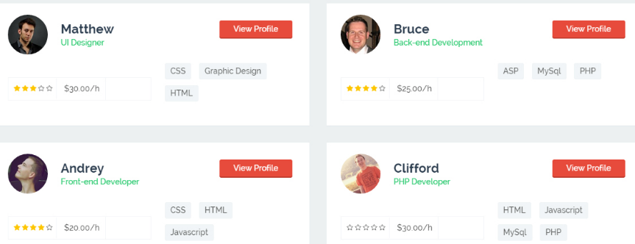

* Then the user should decide the person who would answer his question, on the other side the responder will receive a notification on the website or mobile even by SMS according to his preference and available time he agreed to receive question within

so he can answer the question immediately

* Once the question has answered, a notification will send back to the person who asked the question with the answer and asking him to rate it which affect the quality score of responder, then the question and answer published in the public hub to receive reviews and being checked by other users who could ask the same question

**Note**:

by default, any user would ask a question he first automatically directed to the public hub for a similar question that could answer him and that before being assigned to any of online user who are avialble to recive questions

The user who answered a question will be claim money according to the number of persons who accessed the public hub and viewed his answer the more viewers he would get the more money he will win also the quality of his answer will higher his rank in search result appears for asking users.

Eureka! Matching Algorithm

To explain this part we will not go deep into technical details and complicated calculations about how the algorithm would work to achieve the perfect matching between the user who asks and the other user with perfect answers

Instead, we will focus on the Algorithm logic beyond making the link between question and perfect person to answer it

The algorithm mainly depends on information provided by the user when he registered his profile at the beginning.

Eureka!, collect all data range from his basic information such as photo and name to his interests, hobbies and area of knowledge, that also include other interest and information abstracted from his social media accounts.

**Note:** information collected from user social media accounts will be used to send him suggestions about other are of knowledge or interests that he could answer about in case that he has not mentioned them when he registered his profile at area of interests

let’s assume that there's a user who needs to know someone who lives in Dublin and from Egypt to tell him about the best places to visit and the cheapest budget to stay for a week for an Egyptian ?

So, the algorithm will work on the question after divided it into keywords like (Dublin, Egypt ,vacation, travelling, budget, places )and match them with tagged keywords from user profile and calculate the variables to get the best matches

like to sort users who are lives in Dublin -- from egypt -- and interested in travel --who accepted to receive a question about tourism in Dublin -- and already online according to available times they determined to receive question …

then a list of all available users who match the criteria will appear to the asked user

**Note:** Algorithm will also validate question and will direct user who asking duplicated question to public hub where he would answers that match his question

Also, Algorithm will filter all inappropriate questions that violate the solution agreements and terms of service for questions like porn, drugs, racism and non-ethical questions

Eureka!, **Show** **Time for The Big Data Analytics!**

Now, it’s the time for the real deal where we can make use of the valuable data that we have from our user's interactions using the information that they have provided in their profiles and data collected as well from their social media websites that could include data range from users basic information like his name, age, mobile number or location to critical data about users like their PayPal or bank accounts, their modes, what they like or hate .

Also questions and their answers well help a lot to know what is the general trends for users regarding different topics and what is the topics they frequently asking about, what is the topics which they rarely mention, we can read their impression, their level of knowledge, their feelings towards different subjects

Now can you imagine the treasure of data that we have just generated?

A sub solution will be attached to our system with the name Eureka! insights which will be our business solution that could provide a different wide range of information services to corporate for example:

**Artificial intelligence & Discovery Solution:** imagine how much cognitive solution will be keen to make use of your Q & A knowledge base that contains different topics with best answers from the experts and the most talented person in different interests and fields, more ever the high speed to response and get the answer on the spot

**Smart surveys :** now you can guarantee a new era of surveys for your clients as now you will be able to select a targeted sample for your client survey who best match your client needs and get results faster than any other ways exist in the market because your sample member are ready to answer you and ken to do that ASAP.

So whatever the survey you need we can create it for you in minutes include needed analytics and graphical conclusions

**Consumer and Market behaviour:** when you know your user's interests, what they like or hate, even their feeling against different subjects around.

So, how easy it would be to create consumer or market behaviour towards some variables?

**General Insights & Trends:** now there's no limits or complications for type of insights or trends that any client would need we have answers for different questions and we can create immediate answers for new questions beside smart analytics that we could create, so the power will be really in your hand

Eureka!, **what about the partnership programme?**



In order to maintain the success of Eureka! project you need to keep 4 important pillars in a continuous increase

These pillars are:

1. The base of users
2. The base of Q&A
3. The fastest response for each single question
4. The quality of each answer

And that why we decided that creating a partnership programme will be highly important in order to keep the 4 mentioned pillars in continuous increase, so the success of the project

The analytical & business side will not be really reliable without a good base of active users who keen to answer questions in an efficient way and ASAP.

Money is the best method to attract users and encourage them to receive more question and being available more time to give the perfect answers and enhance their rank that will help them receiving more question cause of their priority in search results

Right now, there's no solution in the world that let you receive real money directly just for answering such simple question about your interests or your area of knowledge that not required to be in a complicated field

You can answer questions about your favourite city, favourite sport, your professional career or any other fields that you could give solid answers about.

and always remember if you answer was not the perfect you will receive a low-quality score from users and that will reduce your chances to get more view for your answers in the public hub so you will not earn the money you target from your answer

Users will claim money according to the number of views for their answer in the public hub and question with answers will be sorted according to users rate for the answer.

From another hand Eureka! will allow advertisers who are interested in advertising in Eureka! for its users large base to bid on keywords related to their industry and their advertisement will appear beside search results for public hub similar question or beside available profile who are available to give immediate answers

Also, premium accounts will be available with conditions for individual and corporate users who decided to give their answers for money cause of its nature like Doctors, lawyers or consultancy firms, Eureka! will get a percentage from these accounts for each paid question

Eureka! Originally provide a free service to encourage everyone asking all questions they need, so users will claim money as partners with tiny ratio from advertising and surveys revenues according to the traffic they create with their answers defined by number of viewers

Eureka!, **Now what is in your mind?**

Let's make it in Eureka! Way (Q & A)

Q: What is the different between Eureka! & Quora I can’t see any difference?



Answer: Ok, maybe you need to ask Eureka! to change your mind because there are a lot of differences between them that we will list for you that make Eureka! more advanced ,for example but not limited

* You got the answer immediately

unless your question is not already exist in our public hub, you will be directed to the online experts who are the best persons to answer your question, who care to provide you with the answer in an efficient way to keep their rank and quality score

* You select who to answer your question

Unlike quora where you submit your question and wait to receive the answer and maybe you will not receive any, because no one was available to answer your question when you submit it or the person who would be able to answer it have not caught by your question or was not interested to answer it , even you can find some answer with full of neglection that could not be considered as answers

In Eureka! you will receive a list of online persons who could give you the best answer and you are the one who decides who could give you the answer, also the person who will answer your question will be happy to receive your question that he receives in his available time and get paid for

* You are our partner

Eureka! Users will get paid for their answers that considered as highly interactive by other users who was searching for the answer in a good quality, as Eureka! users are our partners not like Quora where you do that as a volunteer

Q: what are guarantees for quality and high rapid response for the different question?

Answer: Eureka! The algorithm has designed to act as a social search engine to match questions which best users to answer taking into consideration their available time that they have mentioned in their profile or his login that monitored by Eureka! , that to guarantee the availability besides that user will receive question on his mobile or SMS to be able to answer at any time from anywhere, as partners users always care to provide quick answers with the highest quality to keep their rank and make real money

Q: Eureka! is that project really deserve the investment?

Answer: I will not answer that directly but will give you a figure about similar projects and amounts of investment, so you still remember Quora that website that we criticised it and lose the comparison versus Eureka! , do you know the amount of investment for that website?

# With $80 Million in New Capital, Quora Still Has No Business Model

Source wall street Journal, Apr 9, 2014, 9:00 am ET

However, it’s not profitable like Eureka! With no plan or real business model for future development

We will be able to create revenue with the triple revenue sources

Business solution services, advertisers or sponsors & premium accounts

Is there anything else you need to know about Eureka! ?

You are welcome anytime to ask about our Eureka! project with more details and real visibility study

The project idea and solution design have made by

Wa’el Muhammad

Data Architect /IBM SWF Talent Insight

[WMuhamma@ie.ibm.com](mailto:WMuhamma@ie.ibm.com)

 Version 1.0

26/4/2020